Name: Aliu Habeeb Aremu

Matric No: Ncsf/19/0131

Course Title: web tech

Assignment

SOURCE CODE

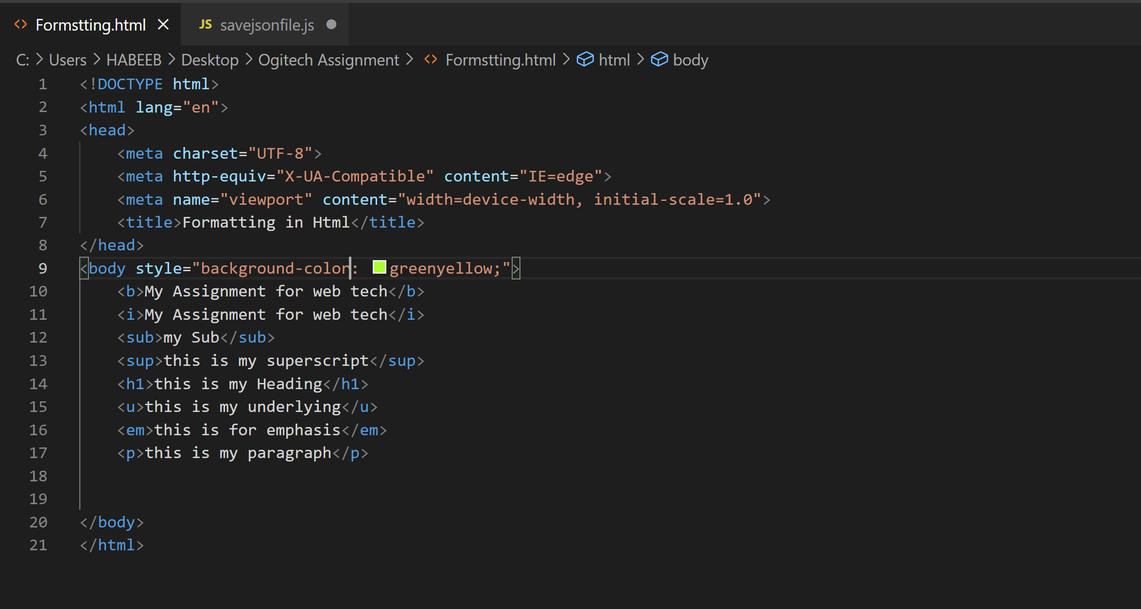

RESULT

